Share Drive Mapping for Mac

- Select Finder from the Task Bar. Once selected use the “Go” menu at the top of the screen,

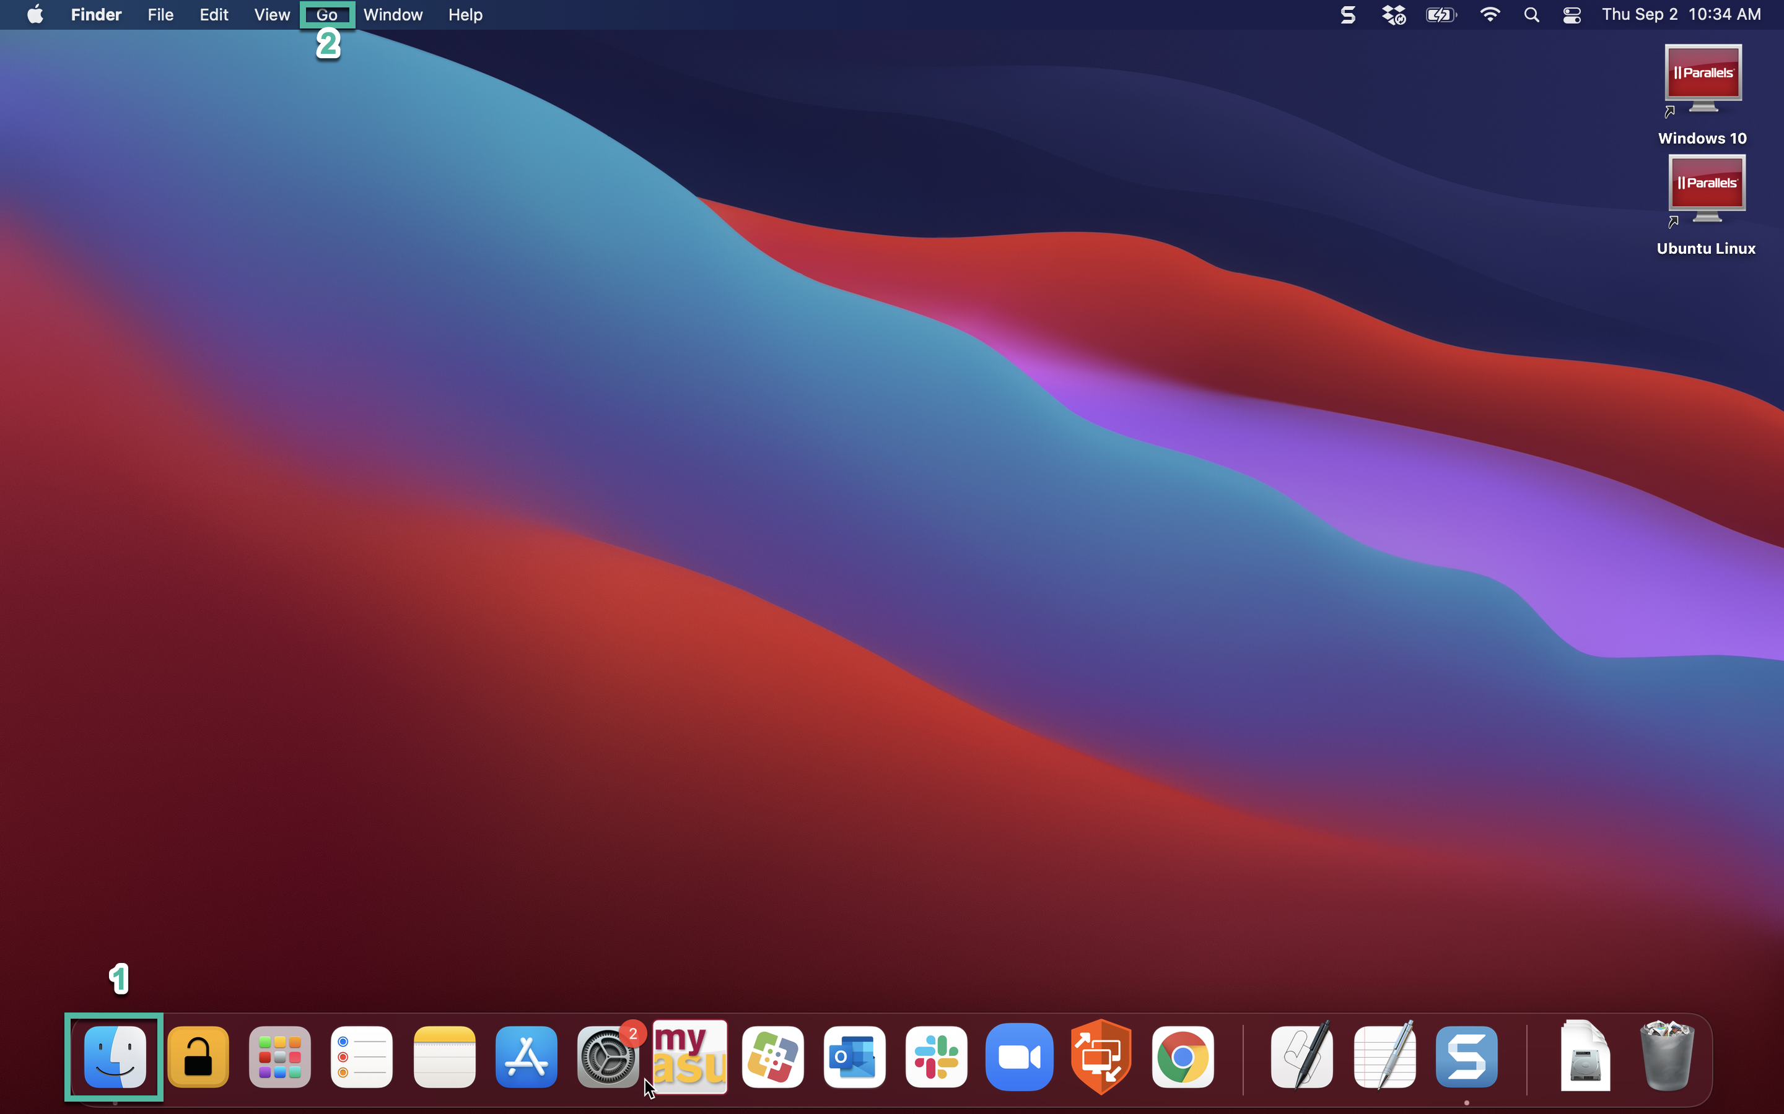

- Under the “Go” menu select “Connect to server…” at the bottom,

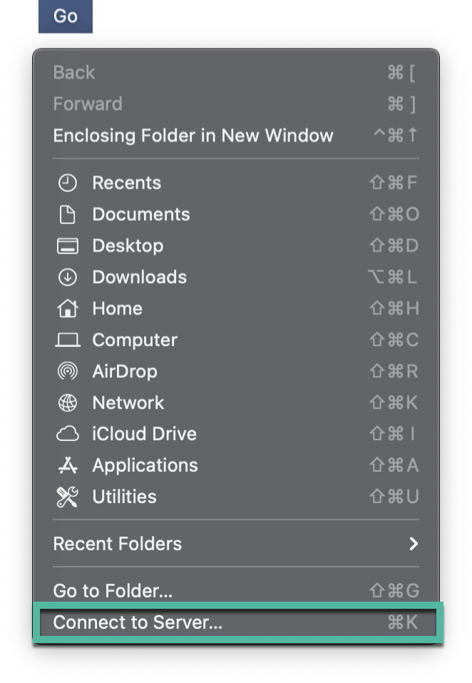

- On the “Connect to Server” window enter the path to your specific folder. Add the server to your favorites by hitting the + button. Hit connect and it will map the share drive.

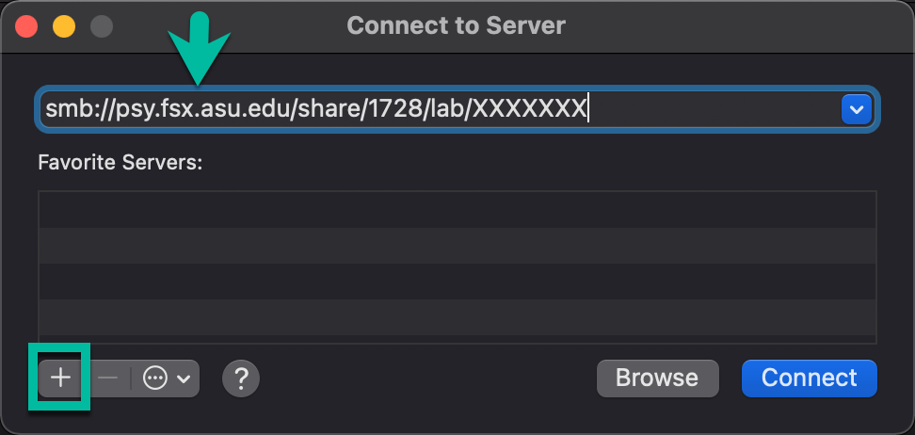

- Once you hit Connect it will ask for your credentials. Enter your ASURITE ID and your ASU password. Some positions such as TA’s and RA’s may have to use the format asuad\ASURITE ID.

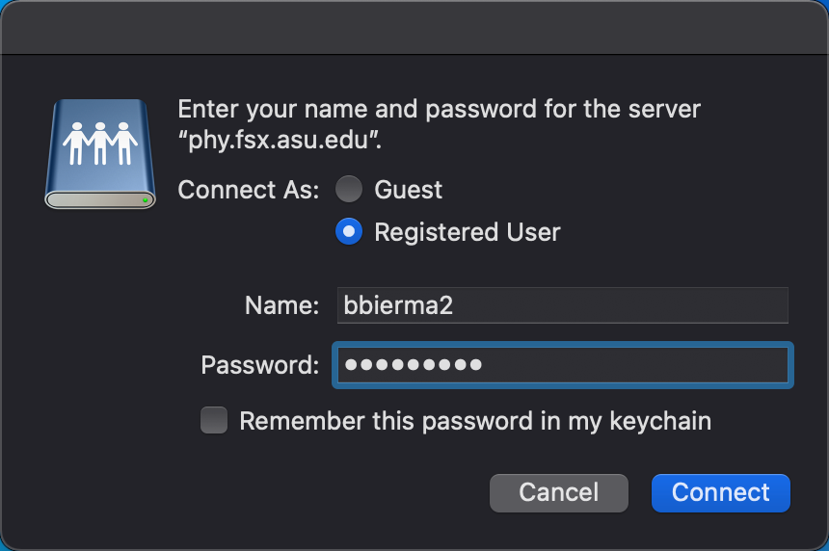

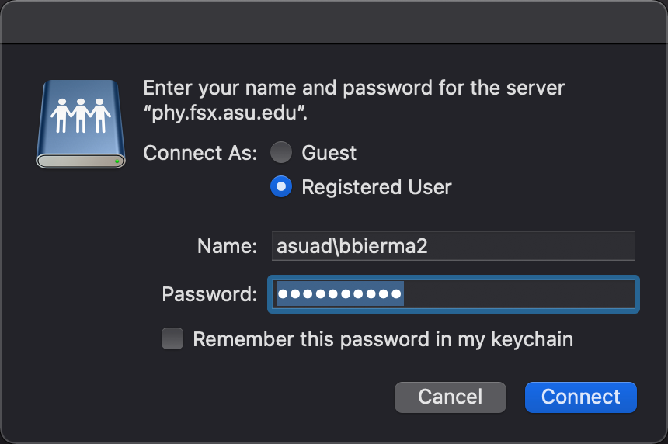

If you restart your machine or logout you will need to use “Connect to Server” and hit connect again.

