Share Drive Mapping for Personal PC’s

- Open File Explorer,

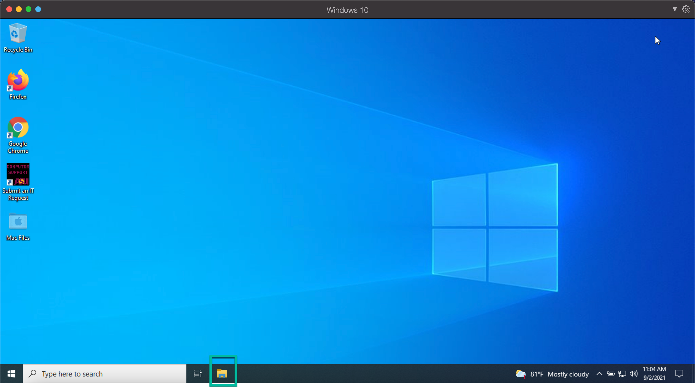

- Once File Explorer is open hit the “Computer” tab at the top. Then select “Map network drive”

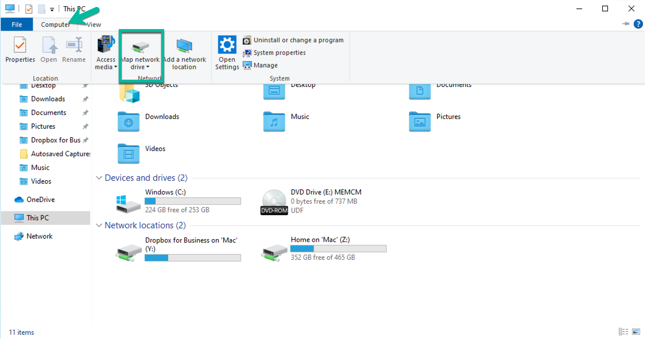
- On the next screen you will need to select the drive letter, Enter the folder path, and check the two checkboxes as shown below. Make sure to use the path for your specific folder.

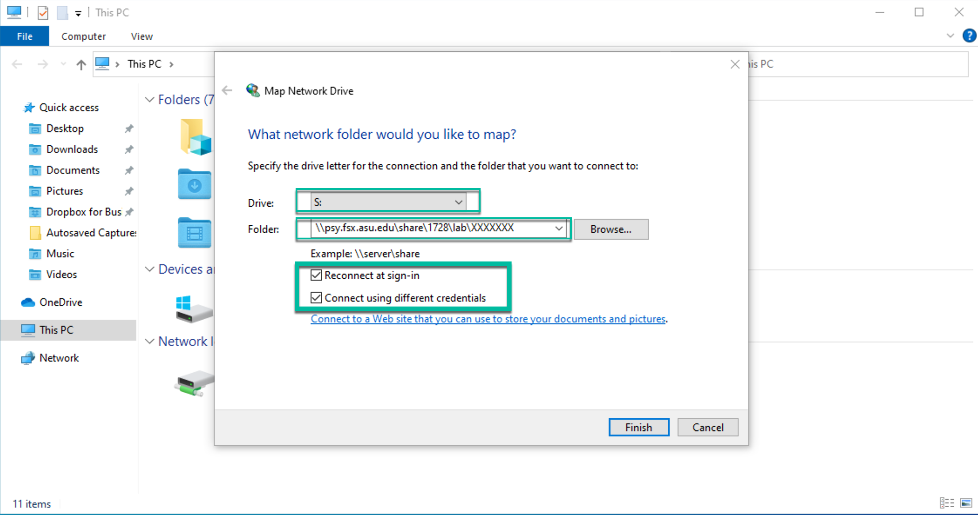

- The next screen will ask for your credentials. Please enter your ASURITE ID and ASU Password in the format shown below. Some positions such as TA’s and RA’s may have to use the second format.

