Are you interested in working with Elementary school age children?
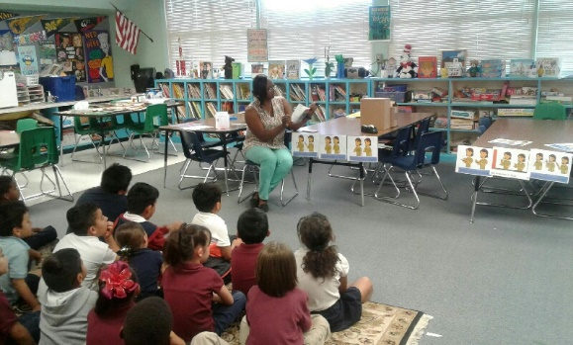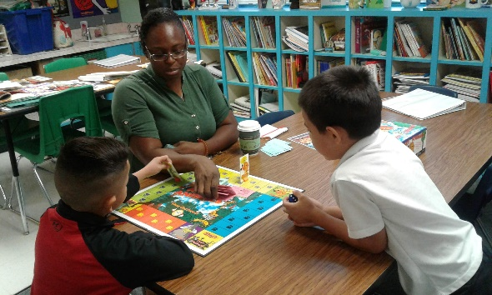
This internship site might be for you. PT Coe Elementary School is looking for ONE more intern for Fall 2019. Must be available for hours M-W. This is a K-5 Elementary School. You would be working with the School Counselor who follows the ASCA model of school counseling which means you will help in providing a comprehensive counseling program.
Internship Responsibilities:
- Assist the counselor with school wide prevention lessons
- Assist with counseling students who have behavioral, academic, or social/emotional challenges
- Assist in group or individual student activities
- Assist the counselor with school wide activities such as setting up assemblies and creating bulletin boards
Intern Requirements:
- 10 hours per week, Monday, Tuesday, and/or Wednesday
- Keep a daily log
- Show finger print card and ID card
- Must be a Junior or Senior at ASU with 2.75 GPA or higher
To Apply: Please email Ms. Delrose Egwu - School Counselor degwu@isaacschools.org

